USER CREATION

- Login at http://72.14.176.42

- Click Administration > User
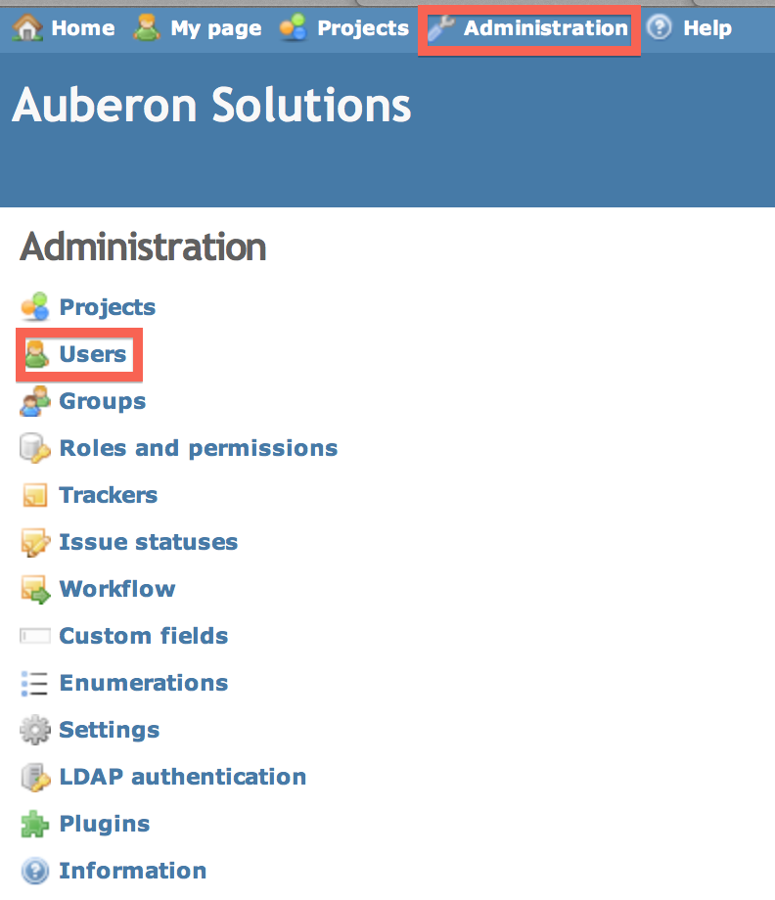

- In the upper-right corner, click “New User”
- Fill out all details as seen in the image, take note of the naming standard.
- Click “Create” or “Create and Continue” if you have several accounts to create

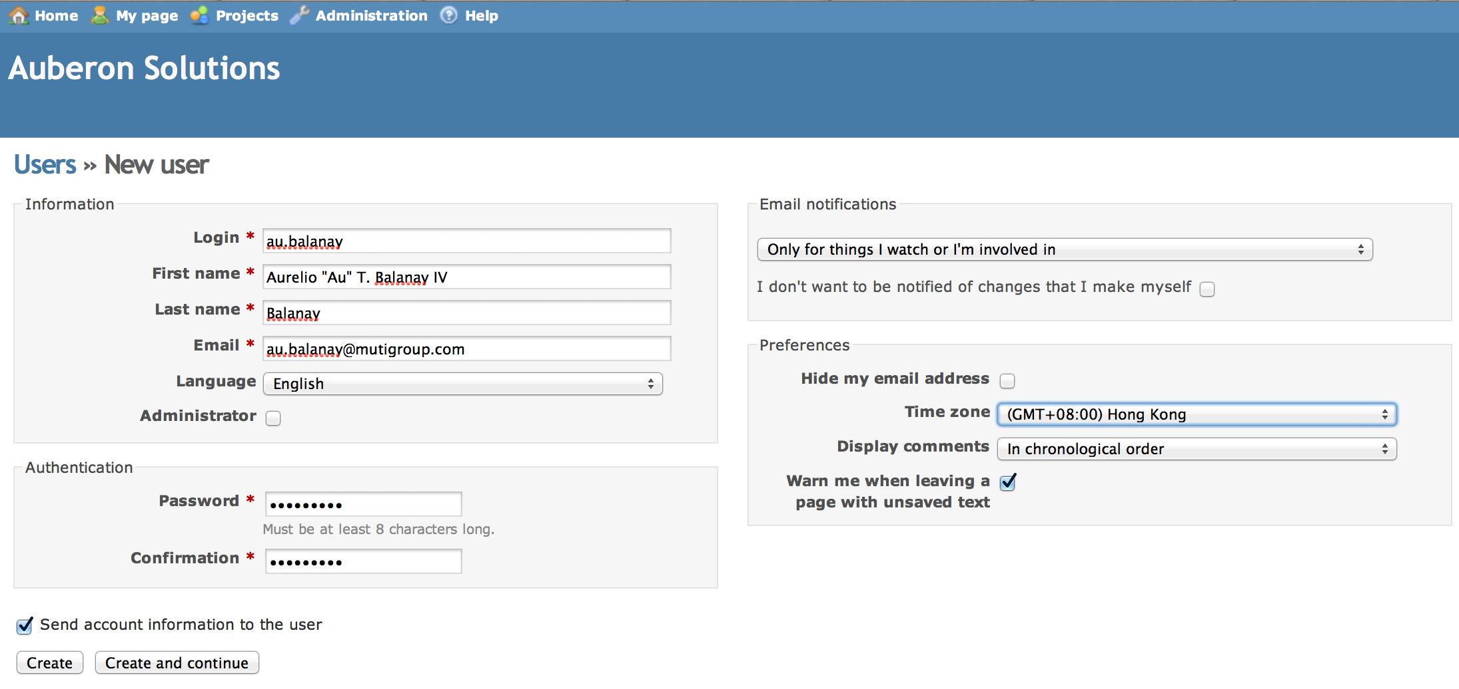

USER DELETION

- Login at http://72.14.176.42

- Click Administration > User

- Search for the user to delete, click “Lock”

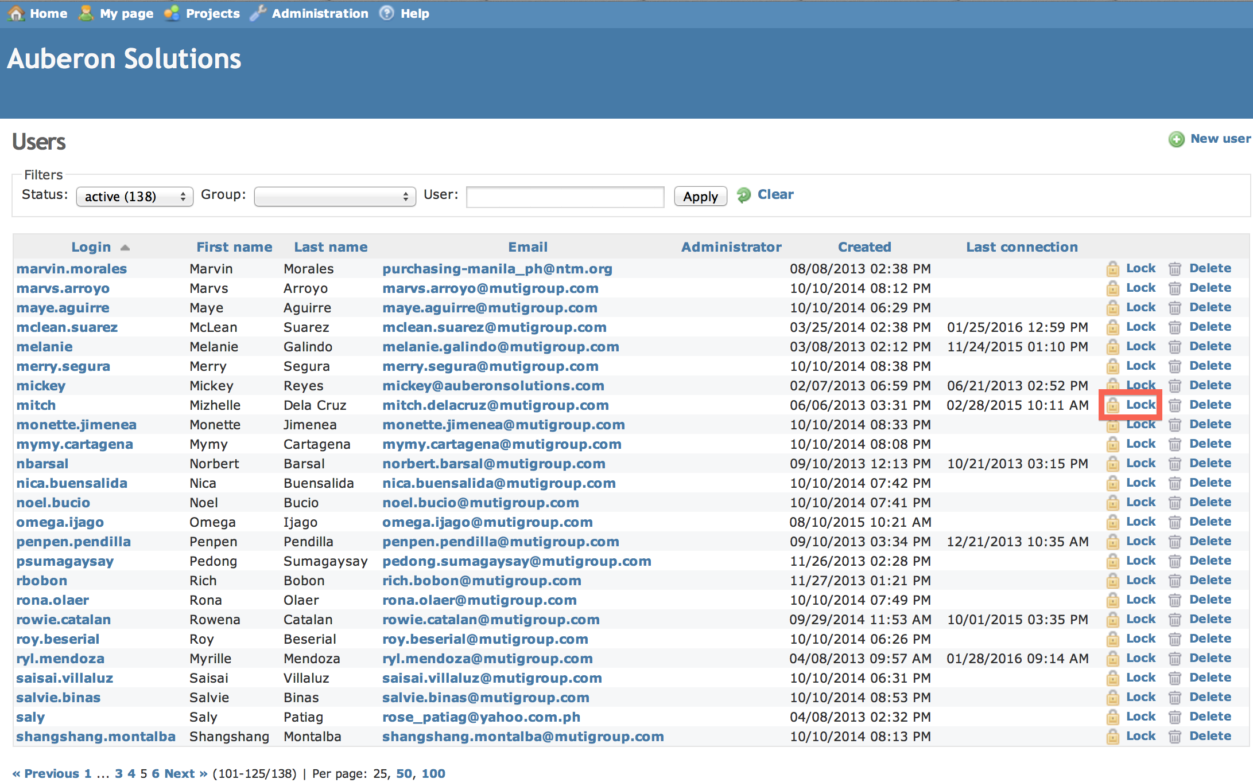

- Set email notifications to “No events”, then click ‘Save’.

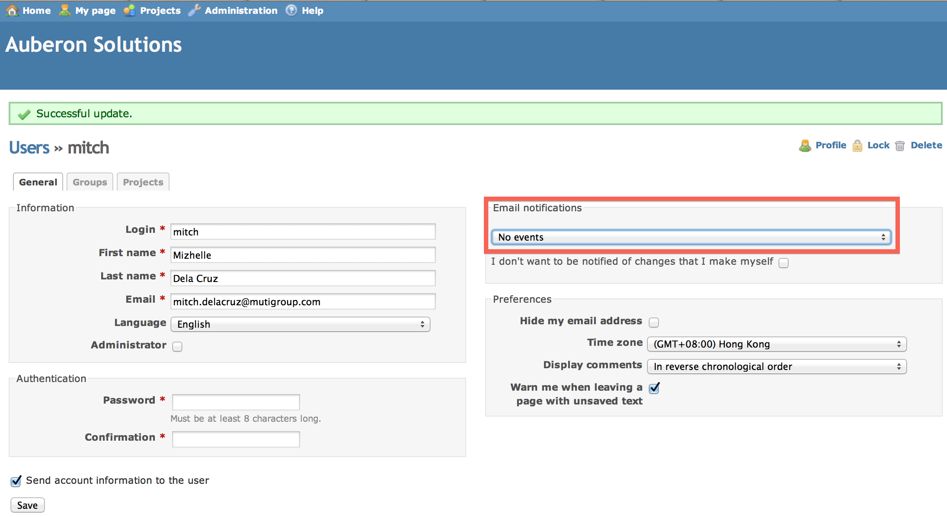

- Click the username, go to the “Group” tab, remove all assignments then click ‘Save’.
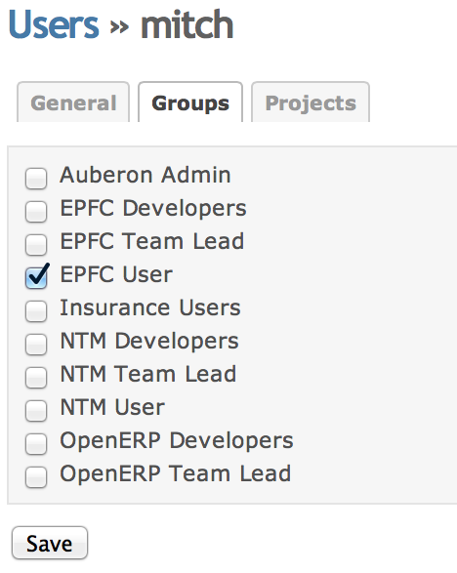

- Go to the “Projects” tab, remove all projects by clicking the trash icon.

